#### **PHYSICS 12**

#### **Atomic Physics Topic Test 2019**

#### **Question/Answer Booklet**

**NAME: ____________________________________**

#### **Time allowed for this paper**

Reading time before commencing work: 3 minutes

Working time for paper: 42 minutes

**STRUCTURE OF THE PAPER**

|  |  |  |  |  |
| --- | --- | --- | --- | --- |
| Section | No. of questions | No. of questions to be attempted | No. of marks out of 41 |  |
| A: Short Answers | 5 | ALL | 11 |  |
| B: Problem Solving | 3 | ALL | 30 |  |
| C: Comprehension |  |  |  |  |

**Section A: Short Answer**

Marks Allocated: 11 marks out of 41 total marks.

This section has 5 questions. Answer the questions in the spaces provided.

**Question 1 (3 marks)**

Photons of wavelength 290 nm are incident on a metal plate. The work function of the metal is 4.1 eV. Calculate the maximum kinetic energy of the emitted electrons.

**Question 2 (3 marks)**

Line **X** on the graphs below shows how the maximum kinetic energy of emitted photoelectrons varies with the frequency of incident radiation for a particular metal.

Which graph shows the results for a metal **Y** that has a higher work function than **X**?

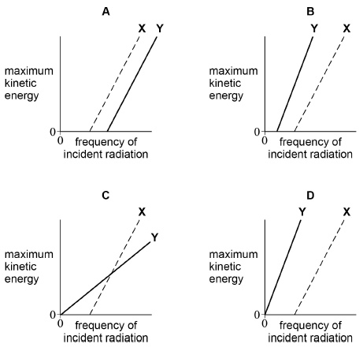

|  |  |
| --- | --- |
| **A** |  |
| **B** |  |
| **C** |  |
| **D** |  |

Explain your choice. Include a sketch of a graph if this helps your explanation.

**Question 3 (3 marks)**

A line emission and a line absorption spectrum of a particular gas were observed. Describe the differences observed between these two spectra.

**Question 4 (1 mark)**

Which statement suggests that electrons have wave properties?

Tick (✔) the correct answer.

|  |  |  |
| --- | --- | --- |
|  | Electrons are emitted in photoelectric effect experiments. |  |
|  | Electrons are released when atoms are ionised. |  |
|  | Electrons produce dark rings in diffraction experiments. |  |
|  | Electron transitions in atoms produce line spectra. |  |

**Question 5 (1 mark)**

In an experiment to demonstrate the photoelectric effect, a charged metal plate is illuminated with light from different sources. The plate loses its charge when an ultraviolet light source is used but not when a red light source is used.

What is the reason for this?

|  |  |  |
| --- | --- | --- |
| **A** | The intensity of the red light is too low. |  |
| **B** | The wavelength of the red light is too short. |  |
| **C** | The frequency of the red light is too high. |  |
| **D** | The energy of red light photons is too small. |  |

**Section B: Problem Solving**

Marks Allocated: 30 marks out of 41 total marks

This section has 3 questions. Answer the questions in the spaces provided.____________

**Question 6 (10 marks)**

(a)     Light has a dual wave-particle nature. State and **outline a piece of evidence** for the wave nature of light and a piece of evidence for its particle nature. For each piece of evidence, outline a characteristic feature that has been **observed or measured** and give a short **explanation** of its relevance.

**(6)**

(b)    For a proton of kinetic energy 5.0 MeV,

(i)      calculate its speed

**(2)**

(ii)     calculate its de Broglie wavelength.

**(2)**

**Question 7 (8 marks)**

When a clean metal surface in a vacuum is irradiated with ultraviolet radiation, electrons are emitted from the metal. The following equation relates the frequency of the incident radiation to the kinetic energy of the emitted electrons.

*hf* = *ɸ* + *Ek*

(a)     Briefly statewhat each of the following terms represents in the above equation.

(i)      *hf*

(ii)     *ɸ*

(iii)    *Ek*

**(3)**

(b) (i)      State what would happen to the number of photoelectrons ejected per second if the ultraviolet source were replaced by a source of red light of the same intensity but of frequency less than *ɸ*/*h*.

**(1)**

(ii)     What would the **wave theory of light** predict about the effect of using the red light source instead of an ultraviolet source?

**(1)**

(iii)    Use the **photon theory of light** to explain the effect of using the red light source instead of an ultraviolet source.

**(3)**

**Question 8 (12 marks)**

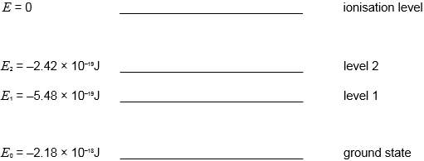

The diagram represents some of the energy levels of an isolated atom. An electron with a kinetic energy of 2.0 × 10–18 J makes an inelastic collision with an atom in the ground state.

1. Calculate the speed of the electron just before the collision.

**(2)**

(b)     (i)   Show that the bombarding electron can excite the electron in the atom to excitation level 2.

**(2)**

(ii)   Calculate the wavelength of the radiation that will result when an atom in level 2 falls to level 1 and state the region of the spectrum to which this radiation belongs.

**(3)**

(c)     Calculate the minimum potential difference through which an electron must be accelerated from rest in order to be able to ionise an atom in its ground state with the above energy level structure.

**(2)**

1. An atom can be excited by bombardment by electrons or by bombardment by photons. Explain why, for a particular transition the photon must have an exact amount of energy whereas the free electron only needs a minimum amount of energy.

**(3)**